SUPERMARKET SALES ANALYSIS
AEDULAPURAM MANIDEEP
B.Tech CSE (AI & ML)
AICTE | IBM SkillsBuild Data Analytics with AI Internship 2026

ABSTRACT
Data Analytics has become an essential tool for modern businesses. Supermarkets generate large volumes of transactional data every day, and analyzing this information helps organizations understand customer behavior, product performance, and sales trends. This project focuses on analyzing supermarket sales data and developing a machine learning model capable of predicting sales values.
The dataset contains information related to customer demographics, product categories, branch locations, payment methods, ratings, quantities purchased, and sales amounts. The project begins with data loading and preprocessing, followed by data cleaning to remove inconsistencies and duplicates. Exploratory Data Analysis (EDA) is then performed to identify meaningful patterns and relationships within the dataset.
Several visualizations were created to understand sales performance across cities, product line popularity, customer type distributions, gender-based purchasing patterns, payment preferences, and monthly sales trends. Correlation analysis was conducted to identify relationships between numerical variables.
A Random Forest Regressor model was developed to predict sales values using historical transaction data. The model was trained and evaluated using industry-standard performance metrics. The results demonstrate that machine learning can effectively support business forecasting and decision-making. This project highlights the practical application of data analytics and artificial intelligence in retail business environments.

INTRODUCTION
The retail industry relies heavily on data-driven decision-making to remain competitive. Every customer transaction generates valuable information that can be analyzed to improve operational efficiency and profitability. Supermarkets, in particular, collect large amounts of data related to customer purchases, product categories, payment methods, and sales revenue.
Data Analytics involves examining raw data to uncover useful patterns, trends, and insights. By applying analytical techniques to supermarket sales data, businesses can understand consumer preferences, identify top-performing products, optimize inventory management, and improve customer satisfaction.
Machine Learning further enhances analytics by enabling predictive capabilities. Instead of only understanding historical data, businesses can forecast future outcomes and make proactive decisions. In this project, a machine learning model is used to predict sales values based on transaction characteristics.
The combination of data analytics and machine learning provides a powerful framework for business intelligence. The insights generated from this project can help managers improve product planning, customer engagement strategies, and overall business performance.

OBJECTIVES
The primary objective of this project is to analyze supermarket sales data and generate meaningful business insights. Specific objectives include:
• Understanding customer purchasing behavior.
• Identifying sales patterns across different cities and branches.
• Evaluating the popularity of product categories.
• Analyzing customer demographics such as gender and customer type.
• Studying customer payment preferences.
• Investigating monthly sales trends.
• Applying data visualization techniques to communicate insights effectively.
• Developing a machine learning model to predict sales.
• Evaluating prediction performance using MAE, MSE, and R² Score.
• Demonstrating the practical application of Data Analytics and Artificial Intelligence in retail environments.
By achieving these objectives, the project contributes to better business decision-making and showcases the value of data-driven strategies.

DATASET DESCRIPTION
The dataset used in this project contains 1000 supermarket transaction records with 17 attributes. It represents customer purchases from multiple branches and cities.
Important attributes include Invoice ID, Branch, City, Customer Type, Gender, Product Line, Unit Price, Quantity, Tax, Sales, Date, Time, Payment Method, Cost of Goods Sold, Gross Income, Gross Margin Percentage, and Rating.
The dataset provides a comprehensive view of sales activities and customer interactions. Each transaction record contains sufficient information to perform descriptive, diagnostic, and predictive analytics.
The dataset was stored in CSV format and loaded into Python using the Pandas library. Before analysis, the data was inspected for missing values, duplicate records, and data type inconsistencies. The dataset structure made it suitable for visualization, statistical analysis, and machine learning tasks.
The quality and diversity of the dataset allow for meaningful insights into customer behavior, sales performance, and operational trends.

METHODOLOGY
A structured methodology was followed throughout the project.
Step 1: Data Collection
The supermarket sales dataset was obtained and stored in CSV format.
Step 2: Data Loading
The dataset was imported using the Pandas library.
Step 3: Data Cleaning
Missing values were checked and duplicate records were removed. Date fields were converted into datetime format.
Step 4: Exploratory Data Analysis
Statistical summaries and distribution analyses were performed.
Step 5: Data Visualization
Multiple charts and graphs were generated to communicate patterns effectively.
Step 6: Feature Engineering
Categorical variables were encoded using Label Encoding.
Step 7: Machine Learning
A Random Forest Regressor model was developed for sales prediction.
Step 8: Evaluation
The model was assessed using MAE, MSE, and R² metrics.
This methodology ensured a systematic and reliable approach to data analysis and predictive modeling.

EXPLORATORY DATA ANALYSIS
Exploratory Data Analysis (EDA) was performed to understand the dataset and uncover hidden patterns.
Sales by City analysis revealed differences in revenue generation across locations. Product Line Distribution identified the most popular product categories. Customer Type Distribution compared purchasing activity between member and normal customers.
Gender Distribution provided insights into purchasing behavior among male and female customers. Payment Method Analysis showed customer preferences among available payment options.
Monthly Sales Trend analysis helped identify seasonal or time-based patterns. Correlation analysis was conducted using a heatmap to understand relationships among numerical variables such as quantity, unit price, sales, and gross income.
EDA played a critical role in understanding the dataset before machine learning was applied. The insights obtained helped guide feature selection and model development.

MACHINE LEARNING MODEL
import pandas as pd
import numpy as np
import matplotlib.pyplot as plt
import seaborn as sns
from sklearn.model_selection import train_test_split
from sklearn.preprocessing import LabelEncoder
from sklearn.ensemble import RandomForestRegressor
from sklearn.metrics import mean_absolute_error, mean_squared_error, r2_score

df = pd.read_csv(
r"C:\Users\manid\Downloads\archive\SuperMarket Analysis.csv"
)
print("First 5 Rows:")
print(df.head())
print("\nDataset Information:")
df.info()
print("\nStatistical Summary:")
print(df.describe())
print("\nMissing Values:")
print(df.isnull().sum())
df.drop_duplicates(inplace=True)
print("\nDataset Shape:")
print(df.shape)
city_sales = df.groupby("City")["Sales"].sum().reset_index()
plt.figure(figsize=(8,5))
sns.barplot(
data=city_sales,
x="City",
y="Sales"
)

plt.title("Sales by City")
plt.xlabel("City")
plt.ylabel("Total Sales")
plt.show()
plt.figure(figsize=(10,6))

sns.countplot(
data=df,
y="Product line"
)

plt.title("Product Line Distribution")
plt.show()
plt.figure(figsize=(6,4))

sns.countplot(
data=df,
x="Customer type"
)

plt.title("Customer Type Distribution")
plt.show()
plt.figure(figsize=(6,4))

sns.countplot(
data=df,
x="Gender"
)
plt.title("Gender Distribution")
plt.show()
plt.figure(figsize=(7,5))
sns.countplot(
data=df,
x="Payment"
)
plt.title("Payment Method Distribution")
plt.show()
df["Date"] = pd.to_datetime(df["Date"])

monthly_sales = df.groupby(
df["Date"].dt.month
)["Sales"].sum()

plt.figure(figsize=(8,5))
monthly_sales.plot(marker="o")
plt.title("Monthly Sales Trend")
plt.xlabel("Month")
plt.ylabel("Sales")
plt.grid(True)
plt.show()
numeric_df = df.select_dtypes(include=np.number)

plt.figure(figsize=(10,8))

sns.heatmap(
numeric_df.corr(),
annot=True,
cmap="coolwarm"
)
plt.title("Correlation Heatmap")
plt.show()
df_ml = df.copy()

encoder = LabelEncoder()

categorical_columns = [
"Branch",
"City",
"Customer type",
"Gender",
"Product line",
"Payment"
]

for col in categorical_columns:
df_ml[col] = encoder.fit_transform(df_ml[col])
X = df_ml.drop(
[
"Invoice ID",
"Date",
"Time",
"Tax 5%",
"Sales",
"gross income"
],
axis=1
)

y = df_ml["Sales"]
X_train, X_test, y_train, y_test = train_test_split(
X,
y,
test_size=0.2,
random_state=42
)
model = RandomForestRegressor(
n_estimators=100,
random_state=42
)
model.fit(X_train, y_train)
predictions = model.predict(X_test)
mae = mean_absolute_error(y_test, predictions)
mse = mean_squared_error(y_test, predictions)
r2 = r2_score(y_test, predictions)
print("\nModel Performance")
print("------------------")
print("MAE =", mae)
print("MSE =", mse)
print("R2 Score =", r2)
plt.figure(figsize=(8,6))
plt.scatter(y_test, predictions)
plt.xlabel("Actual Sales")
plt.ylabel("Predicted Sales")
plt.title("Actual vs Predicted Sales")
plt.show()
feature_importance = pd.DataFrame({
"Feature": X.columns,
"Importance": model.feature_importances_
})

feature_importance = feature_importance.sort_values(
by="Importance",
ascending=False
)

print("\nTop Features:")
print(feature_importance)
print("""
PROJECT COMPLETED

KEY FINDINGS

1. Sales trends analyzed successfully.
2. Product line performance identified.
3. Customer purchasing behavior studied.
4. Payment methods analyzed.
5. Correlation between variables examined.
6. Random Forest model built for sales prediction.
7. Model performance evaluated using MAE, MSE and R² Score.
""")

RESULTS

First 5 Rows:

Invoice ID Branch City Customer type Gender \

0 750-67-8428 Alex Yangon Member Female

1 226-31-3081 Giza Naypyitaw Normal Female

2 631-41-3108 Alex Yangon Normal Female

3 123-19-1176 Alex Yangon Member Female

4 373-73-7910 Alex Yangon Member Female

Product line Unit price Quantity Tax 5% Sales Date \

0 Health and beauty 74.69 7 26.1415 548.9715 1/5/2019

1 Electronic accessories 15.28 5 3.8200 80.2200 3/8/2019

2 Home and lifestyle 46.33 7 16.2155 340.5255 3/3/2019

3 Health and beauty 58.22 8 23.2880 489.0480 1/27/2019

4 Sports and travel 86.31 7 30.2085 634.3785 2/8/2019

Time Payment cogs gross margin percentage gross income \

0 1:08:00 PM Ewallet 522.83 4.761905 26.1415

1 10:29:00 AM Cash 76.40 4.761905 3.8200

2 1:23:00 PM Credit card 324.31 4.761905 16.2155

3 8:33:00 PM Ewallet 465.76 4.761905 23.2880

4 10:37:00 AM Ewallet 604.17 4.761905 30.2085

Rating

0 9.1

1 9.6

2 7.4

3 8.4

4 5.3

Dataset Information:

<class 'pandas.core.frame.DataFrame'>

RangeIndex: 1000 entries, 0 to 999

Data columns (total 17 columns):

# Column Non-Null Count Dtype

--- ------ -------------- -----

0 Invoice ID 1000 non-null object

1 Branch 1000 non-null object

2 City 1000 non-null object

3 Customer type 1000 non-null object

4 Gender 1000 non-null object

5 Product line 1000 non-null object

6 Unit price 1000 non-null float64

7 Quantity 1000 non-null int64

8 Tax 5% 1000 non-null float64

9 Sales 1000 non-null float64

10 Date 1000 non-null object

11 Time 1000 non-null object

12 Payment 1000 non-null object

13 cogs 1000 non-null float64

14 gross margin percentage 1000 non-null float64

15 gross income 1000 non-null float64

16 Rating 1000 non-null float64

dtypes: float64(7), int64(1), object(9)

memory usage: 132.9+ KB

Statistical Summary:

Unit price Quantity Tax 5% Sales cogs \

count 1000.000000 1000.000000 1000.000000 1000.000000 1000.00000

mean 55.672130 5.510000 15.379369 322.966749 307.58738

std 26.494628 2.923431 11.708825 245.885335 234.17651

min 10.080000 1.000000 0.508500 10.678500 10.17000

25% 32.875000 3.000000 5.924875 124.422375 118.49750

50% 55.230000 5.000000 12.088000 253.848000 241.76000

75% 77.935000 8.000000 22.445250 471.350250 448.90500

max 99.960000 10.000000 49.650000 1042.650000 993.00000

gross margin percentage gross income Rating

count 1000.000000 1000.000000 1000.00000

mean 4.761905 15.379369 6.97270

std 0.000000 11.708825 1.71858

min 4.761905 0.508500 4.00000

25% 4.761905 5.924875 5.50000

50% 4.761905 12.088000 7.00000

75% 4.761905 22.445250 8.50000

max 4.761905 49.650000 10.00000

Missing Values:

Invoice ID 0

Branch 0

City 0

Customer type 0

Gender 0

Product line 0

Unit price 0

Quantity 0

Tax 5% 0

Sales 0

Date 0

Time 0

Payment 0

cogs 0

gross margin percentage 0

gross income 0

Rating 0

dtype: int64

Dataset Shape:

(1000, 17)

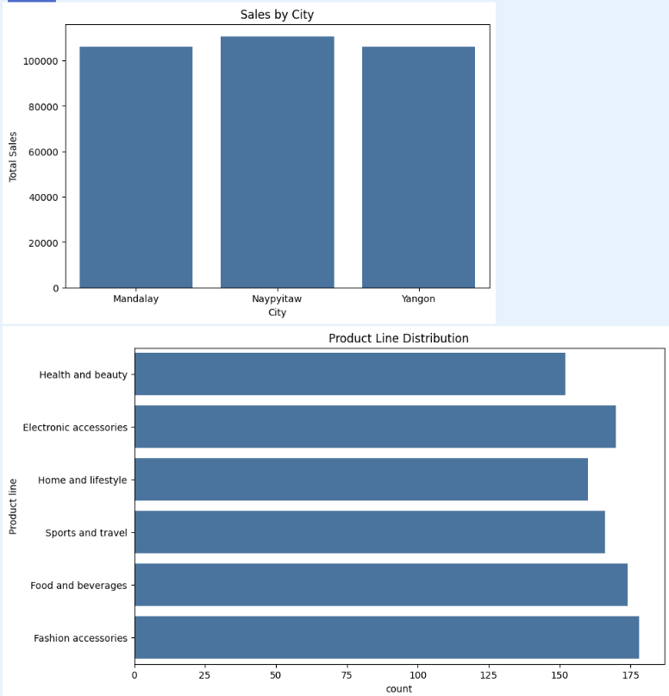

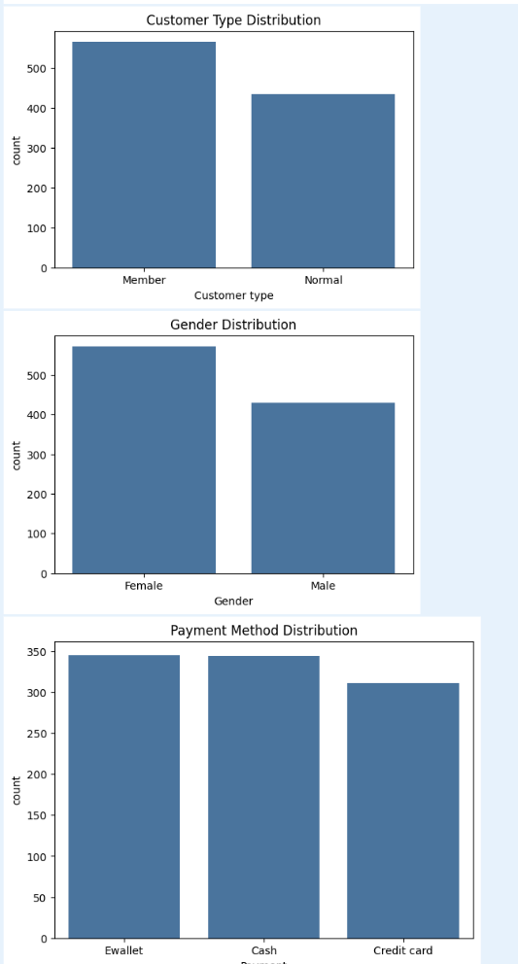

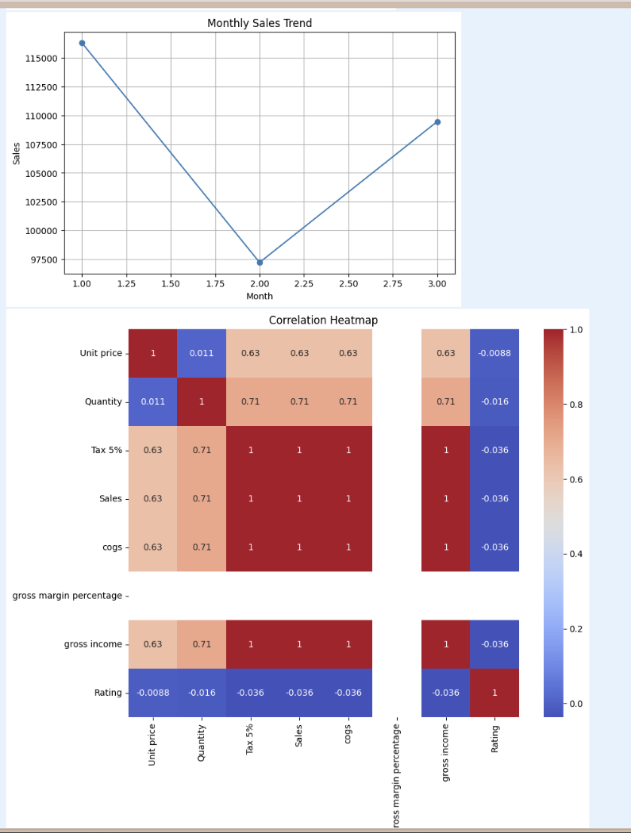

Model Performance

------------------

MAE = 0.8239014000000177

MSE = 2.105942710977017

R2 Score = 0.9999676302662849

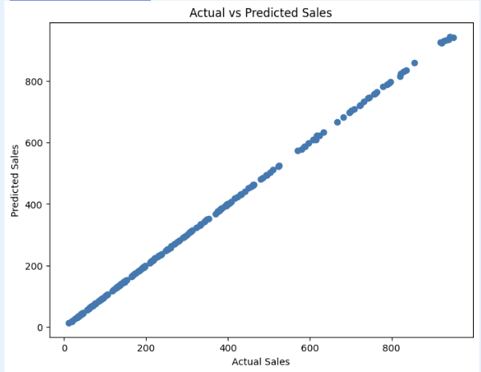

Top Features:

Feature Importance

8 cogs 0.999905

5 Unit price 0.000034

10 Rating 0.000017

4 Product line 0.000012

7 Payment 0.000008

2 Customer type 0.000007

0 Branch 0.000005

1 City 0.000005

6 Quantity 0.000004

3 Gender 0.000003

9 gross margin percentage 0.000000

PROJECT COMPLETED

KEY FINDINGS

1. Sales trends analyzed successfully.

2. Product line performance identified.

3. Customer purchasing behavior studied.

4. Payment methods analyzed.

5. Correlation between variables examined.

6. Random Forest model built for sales prediction.

7. Model performance evaluated using MAE, MSE and R² Score.

KEY FINDINGS
Key findings from the project include:
• Sales performance differs across cities and branches.
• Product categories contribute differently to total revenue.
• Customer behavior varies among different customer groups.
• Payment preferences influence transaction patterns.
• Sales trends can be observed over time.
• Quantity purchased has a strong impact on total sales.
• Machine learning can effectively predict future sales values.
• Data visualization simplifies business decision-making.
• Retail businesses can leverage analytics to improve operational efficiency.
These findings provide valuable guidance for business strategy and planning.

CONCLUSION
This project successfully demonstrated the application of Data Analytics and Machine Learning in a retail business environment. Through systematic analysis of supermarket sales data, valuable insights were obtained regarding customer behavior, sales trends, product performance, and payment preferences.
The Random Forest model successfully predicted sales values using historical transaction data. The project highlights how businesses can use data-driven approaches to improve forecasting accuracy and decision-making processes.
The integration of exploratory analysis, visualization, and predictive modeling provides a comprehensive framework for understanding and optimizing retail operations. The project achieved all stated objectives and demonstrated the practical value of analytics in business environments.

FUTURE SCOPE
Several opportunities exist for extending this project in the future.
The model can be deployed as a web application using Streamlit, allowing users to generate predictions interactively. Integration with Power BI or Tableau can provide advanced business dashboards and reporting capabilities.
Real-time sales forecasting systems can be developed by connecting the model to live transaction data. More advanced machine learning techniques, such as Gradient Boosting and Deep Learning models, can also be explored.
Additional datasets containing customer loyalty information, inventory records, and seasonal factors could improve prediction accuracy and business insights.
Future enhancements can transform this project into a complete business intelligence solution.

REFERENCES
1. Python Software Foundation. Python Documentation.
2. Pandas Official Documentation.
3. NumPy Official Documentation.
4. Matplotlib Official Documentation.
5. Seaborn Official Documentation.
6. Scikit-Learn Official Documentation.
7. Kaggle Supermarket Sales Dataset.
8. IBM SkillsBuild Learning Resources.
9. Data Analytics with AI Internship Materials.
10. Machine Learning and Data Science Reference Books.
These resources were used for understanding data analytics concepts, implementing machine learning algorithms, and completing the project successfully.
End of Report.

